Lecturer’s name: N/A | Date: Day 2
Course: Math 6 | Unit: Operations with Positive Fractions and Decimals
Unit Duration: 10 | Lesson Duration: 1 day
TEKS: 6.3ER | Lesson Part #1
Topic: Multiply Decimals

Lesson objectives:
- I can use knowledge of multiplication as groups of and as the dimensions of an array to multiply decimals.
- I can use hundredths grids to multiply two decimals.
- I can discuss patterns in products and create a rule for multiplying decimals.
- I can estimate the product of decimal

Essential Questions:
- What steps do I take to multiply decimals?

LYS Methodology
Be (Character/Values/Principles) - How does multiplying allow us to have balance, to be independent and resourceful?

Know (What resources are available to the student/ How can they use them) - How can multiplying values help me have a better understanding of how to create more of a given opportunity or value?

Do (Execute with Excellence) - How can this skill help me develop purpose and resourcefulness?

Resources (Include Technology):
Instructional Input - Asynchronous
AS: Anticipatory Set (Introduction)
- Student should practice multiplication of double digit factors with double digit factors -

M: Modeling (I do)
- 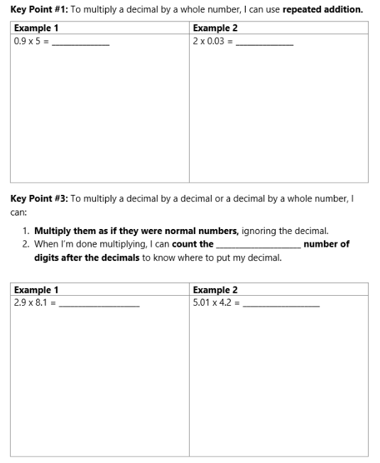
- Teacher will review KP #1 and MODEL Example 1
- Students will complete Example 2
- Teacher will review KP #2, emphasizing step 1 and 2 by completing Example 1
- Students will complete Example 2

CFU (Check For Understanding):
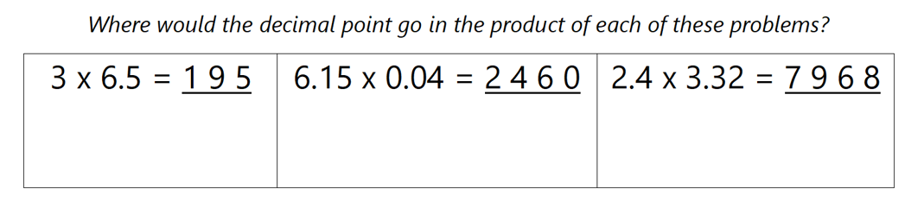
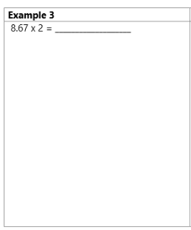
- Include STEPS:
  - Multiply them as if they were normal numbers, ignore the decimal
  - When done multiplying, count the total number of digits after the decimals to know where to put the decimal in the product

GP: Guided Practice (We do)
- Students will complete problems with partners
- 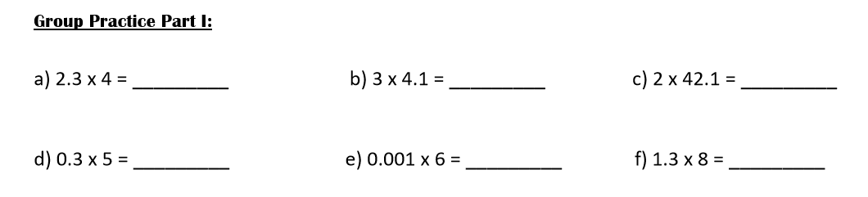
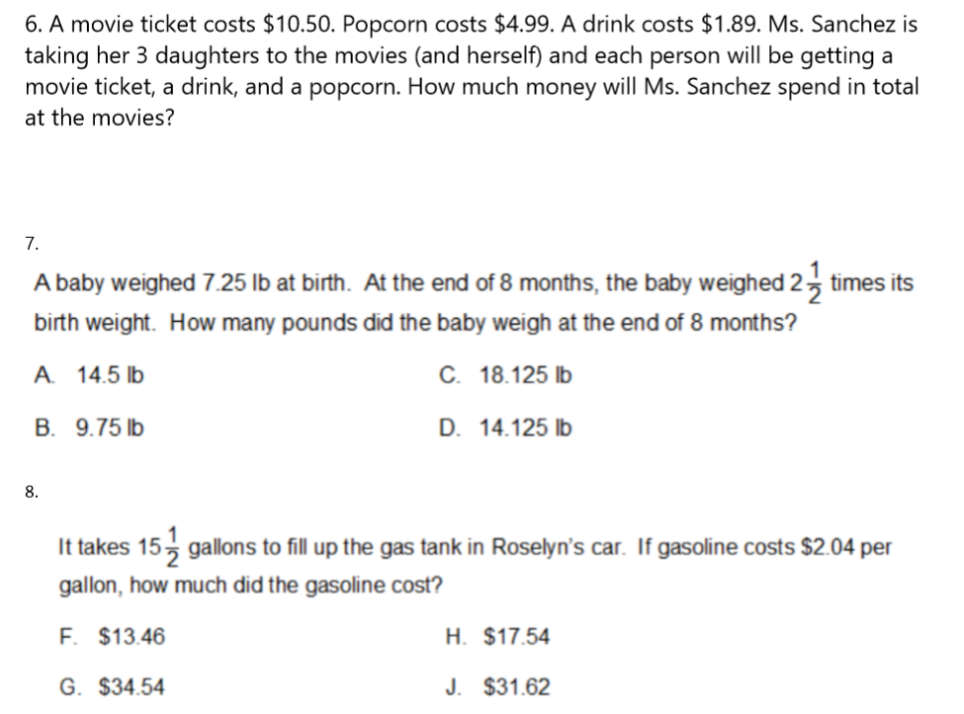

Instructional Input - Synchronous
AS: Anticipatory Set (Introduction)
- Student should practice multiplication of double digit factors with double digit factors -

M: Modeling (I do)
- 
- Teacher will review KP #1 and MODEL Example 1
- Students will complete Example 2
- Teacher will review KP #2, emphasizing step 1 and 2 by completing Example 1
- Students will complete Example 2

CFU (Check For Understanding):


- Include STEPS:
  - Multiply them as if they were normal numbers, ignore the decimal
  - When done multiplying, count the total number of digits after the decimals to know where to put the decimal in the product

GP: Guided Practice (We do)
- Students will complete problems with partners
- 


Independent Practice/ Homework
- 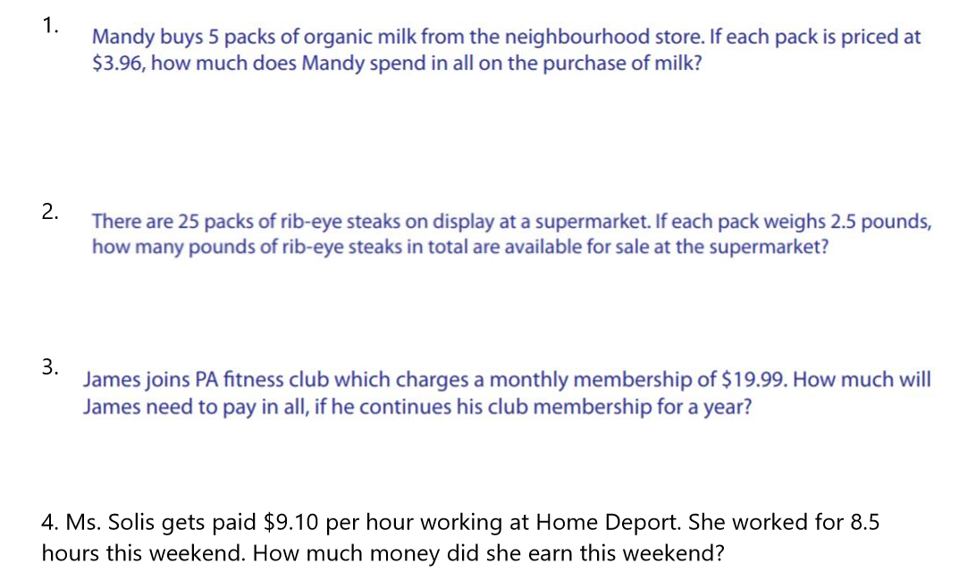

Additional Practice
- Print multiplying decimals worksheets

Lesson Close

“Possabilities do not add. They multiply” - Paul Romer

We use decimals everyday while dealing with money, weight, length etc. Decimal numbers are used in situations where more precision is required than the whole numbers can provide. For example, when we calculate our weight on the weighing machine, we do not always find the weight equal to a whole number on the scale. To know our exact weight, we must understand what the decimal value on the scale means. This section deals with the concept of decimals in three important fields of our daily life.

